U.S. Radiocommunication Sector
Fact Sheet
Working Party: ITU-R WP 7C | Document No: US 7C/27-010NC
Ref.: Document 7C/50 | Date: 8 August 2024
Document Title: NON-CONSENSUS: Proposed draft reply liaison statement to Working Party 4C on WRC-27 agenda item 1.13
Author(s)/Contributors(s):  Daniel Bishop  NASA  Jason Szklany  ADS for NASA | Phone:  Email : Daniel.W.Bishop@nasa.gov  Phone:  Email: jszklany@asrcfederal.com
Purpose/Objective: To provide relevant information to Working Party 4C regarding WRC-27 agenda item 1.13.

Abstract: Working Party (WP) 7C is listed as a contributing group for WRC-27 agenda item 1.13 which will study possible new allocations to mobile-satellite service (MSS) in frequency bands allocated to the mobile service on a primary basis and used for IMT or identified for IMT by country footnotes.
This draft reply liaison statement will serve to provide relevant information to WP 4C.
Non-consensus Status: Objections were raised to mention of the cold sky calibration function that passive sensors perform. The text is indicated in square brackets in Annex 1.
Fact Sheet Preparer: Jason Szklany, ADS for NASA

Radiocommunication Study Groups | 
Source: Document xxxxxxxx  Subject: WRC-27 agenda item 1.13 | Document XX/-E
 | 06 June 2024
 | Original: English
United States of America
proposed reply liaison statement to working party 4C regarding WRC-27 agenda item 1.13

The Administrative Circular CA/270 identifies Working Party (WP) 4C as responsible group and WP 7C as a contributing group for WRC-27 Agenda Item 1.13 which calls for studies on possible new allocations to the mobile satellite service for direct connectivity between space stations and International Mobile Telecommunications (IMT) user equipment to complement terrestrial IMT network coverage.

In document 7C/50, WP 4C requested relevant technical and operational characteristics and protection criteria for frequencies in the frequency range between 694/698 MHz and 2.7 GHz. This document proposes a draft liaison statement that contains characteristics and criteria to be sent to WP 4C in support of any necessary studies on Agenda Item 1.13.

Attachment

Working Party 7c

proposed reply liaison statement to working party 4C regarding WRC-27 agenda item 1.13

Working Party (WP) 7C thanks WP 4C for its liaison statement in Document 7C/50 seeking relevant technical information to support studies supporting Resolution 253 for WRC-27 Agenda Item 1.13. In the frequency bands identified for study in Document 7C/50, the following are bands containing adjacent allocations under the purview of Working Party 7C:

- 1 400-1 427 MHz: This band is subject to RR No. 5.340 (all emissions are prohibited). Information pertaining to this adjacent allocation is located in Annex 1.

Working Party 7C appreciates being kept informed of the status of all studies regarding EESS systems and looks forward to collaboration on other WRC-27 agenda items.
Status: For information and action, if any
Contacts: xxxxxxx xxxxxxx  Xxxxxxx xxxxxxx | E-mail: xxxxxxxxxxx  E-mail: xxxxxxxxxxx

Annex 1
Information pertaining to EESS (passive) allocations in the
1 400-1 427 MHz frequency band.

Interference criteria
The EESS (passive) interference protection criterion for the 1 400-1 427 MHz frequency band is given in Table 2 of Recommendation ITU-R RS.2017-0 with the threshold of –174 dBW/27 MHz to not be exceeded more than 0.1% of time in a measurement area of 10 000 000 km².

System Parameters
Recommendation ITU-R RS.1861-1 provides technical and operational parameters of EESS passive systems including descriptions of sensor scanning configurations. Table 1 is taken from this Recommendation and represents typical system parameters for the 1 400-1 427 MHz frequency band. Additionally, Recommendation ITU-R RS.1861 includes antenna patterns for sensor types A1 and A2 which can be identified in figure 1 and figure 2 respectively. For Sensor type A4, sensor patterns is modeled using Recommendation ITU-R RS.1813-2. [Sensor A4 additionally relies on a calibration process performed while the antenna’s mainbeam is focused away from the Earth’s surface. During this time, the system performs a measurement of the cosmic background to obtain a “cold calibration”. Table 1 includes the dynamics of the sensor during this cold calibration process.]
TABLE 1
EESS (passive) sensor characteristics in the 1 400-1 427 MHz frequency band
 | Sensor A1 | Sensor A2 | Sensor A4
Sensor type | Interferometric radiometer | Conical scan | Conical scan
Orbit parameters
Altitude (km) | 757 | 670 | 820
Inclination (degree) | 98 | 98 | 98.702
Eccentricity | 0 | 0 | 0.0011441
Repeat period (days) | 3 | 3 | 29
Sensor antenna parameters
Number of beams | 1 | 1 | 1
Antenna size | N/A | 6.2 m | 7.4 m
Maximum beam gain (dBi) | 9 | 37 | 39.1
Polarization | V, H | V, H | V, H
−3 dB beamwidth (degree) | 71.6 | 2.6 | 1.89-2.20
Instantaneous field of view | 756 km² | 50.1 × 38.5 km | 77 × 43 km
Off-nadir pointing angle (degree) | 25 | 35.5 | 46.5
Incidence angle at Earth (degree) | 2°/48 | 39.9 | 55
Swath width (km) | 1 000 | 1 000 | >1 900
Antenna efficiency |  | 0.60
Beam dynamics | Fixed | 14.6 rpm | 7.8 rpm
Sensor antenna pattern | Fig. 9 | Fig. 10 | ITU-R RS.1813
Cold calibration antenna gain (dBi) | N/A | N/A | 39.1
Cold calibration angle (degrees re. satellite track) | N/A | N/A | 0 º
Cold calibration angle (degrees re. nadir direction) | N/A | N/A | 45º-180º
Sensor receiver parameters
Sensor integration time | 1.2 s | 84 ms | 55.4 ms
Channel bandwidth (MHz) | 27 | 27 | 27
Measurement spatial resolution
Horizontal resolution (km) | 40 | 39 | 77
Vertical resolution | N/A | N/A | 43 km

FIGURE 1
Sensor A1 antenna pattern for the 1 400-1 427 MHz frequency band
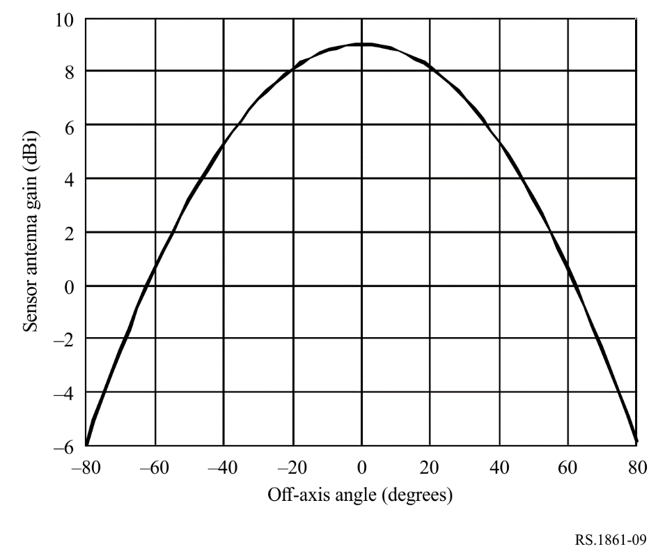
FIGURE 2
Sensor A2 antenna patterns for the 1 400-1 427 MHz frequency band
